Emily Ding

PUI

3/6/20

Assignment 6A

Low-fi:

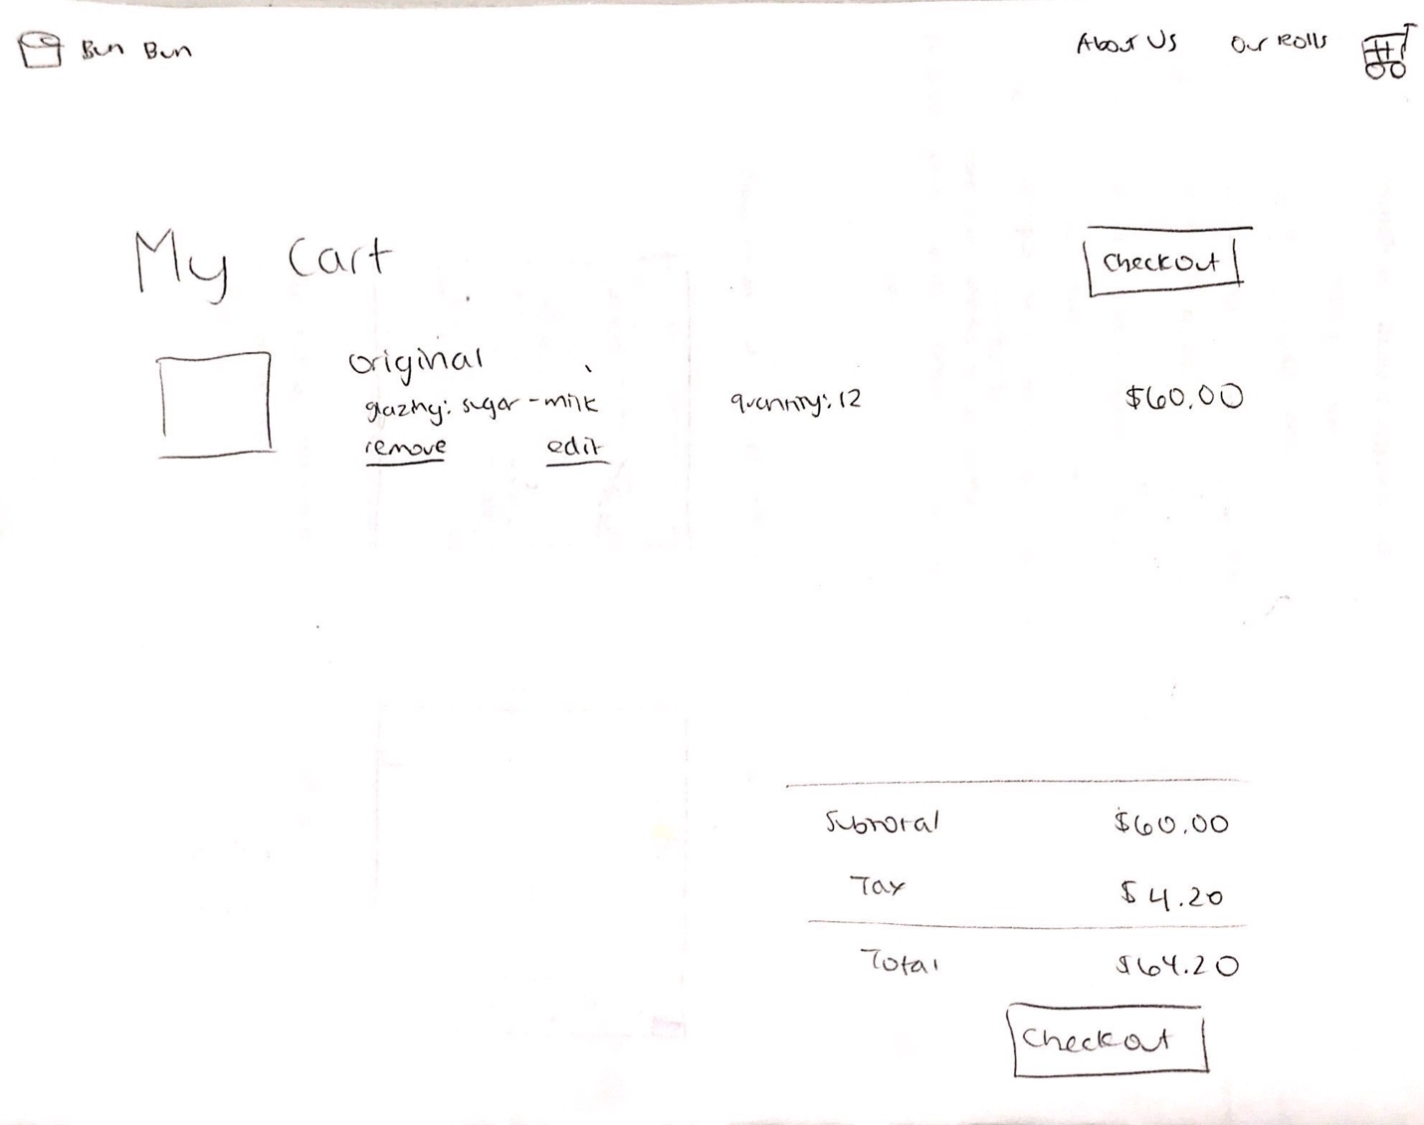

This shopping cart page is based on the general pattern of check out carts for websites. I only included the necessary elements on the page, and have two check out buttons (inspired from the amazon cart example we had seen in an earlier class) so that users don’t have to scroll all the way up or down the page if they have many items in their cart.

High-fi:

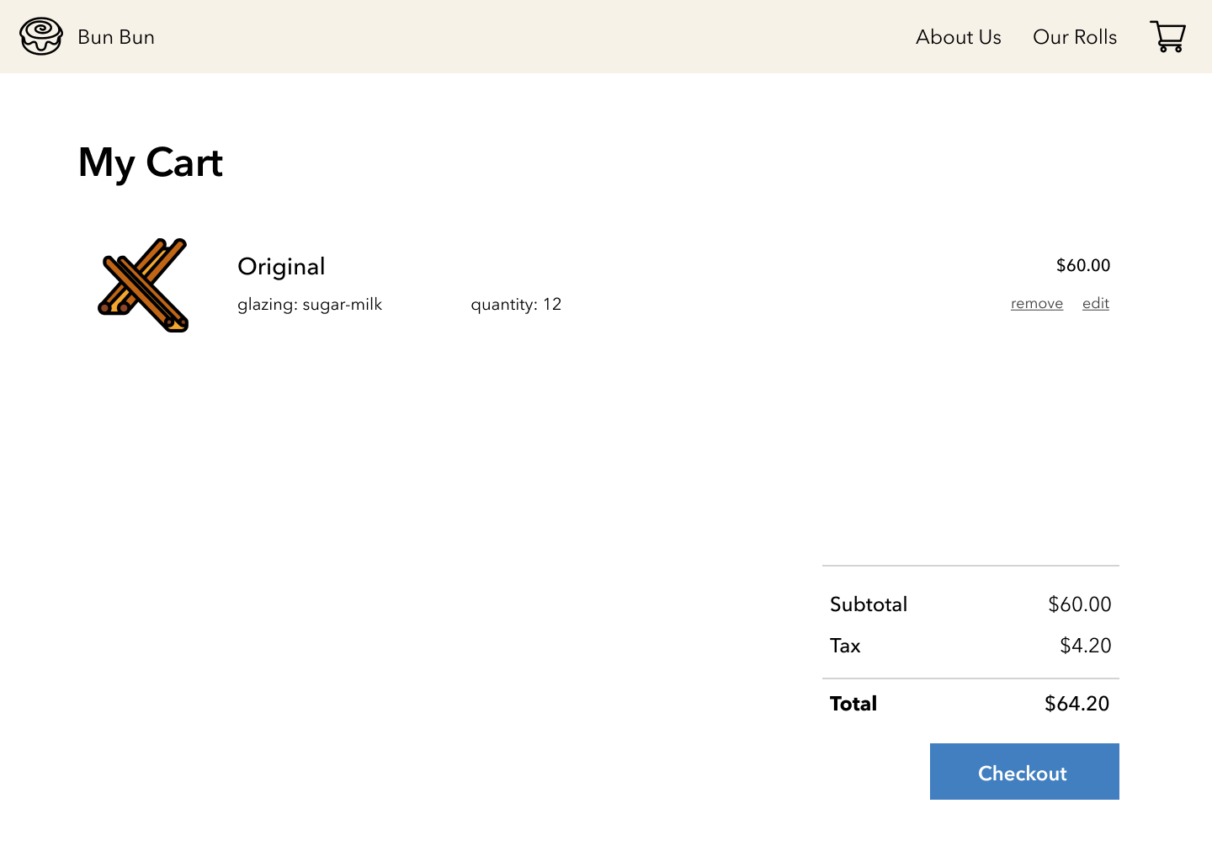

I got rid of the checkout button on the top that I had on my low-fi because it was too distracting and big on the minimalist page. Also, I realized that customers will only have a maximum of six rows of cinnamon buns on their cart page so there won’t be a long scroll. This version seems a lot emptier than my low-fi, mainly due to the size of my texts, but I decided to keep the font size the same for consistency with other pages.